Kanwal Public School’s
Summer Reading is a Blast
challenge!

Keep the reading momentum rolling along by reading for 25 days during
the summer holiday.

To join the Summer Reading is a Blast challenge, please complete the form below and return it to your child’s class teacher by Friday 2nd December 2016.

Students will receive a reading card to complete and return to Miss Trudgeon by Friday 10th February 2017. Students will then receive a book prize.
There is no cost involved, just a commitment to have fun reading through the holiday.

Reading over the holidays helps children maintain or improve the reading level they developed throughout the school year. Children who don’t read over the break can lose core reading skills and slide backwards, potentially falling behind when they return to school.

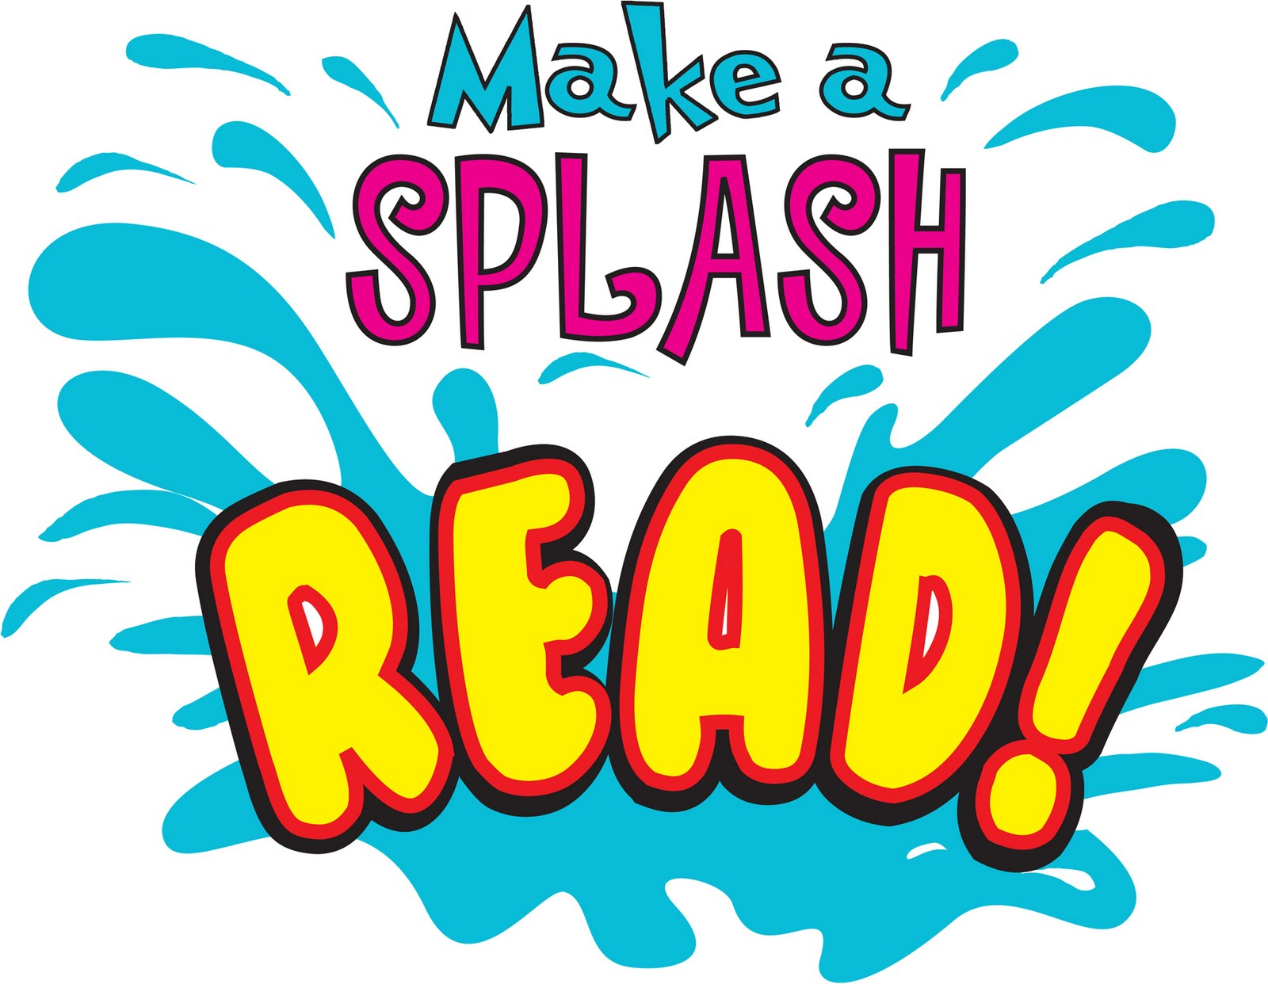

If you have any questions, please contact the school.
Summer Reading Committee Angela Crowe - Principal
_________________________________________________________________

Congratulations! 126 students completed the last Summer Reading is a Blast challenge and received book prizes in February 2016. We would love more children to return completed cards and receive book prizes in 2017. We can do this!
------------------------------------------------------------------
Summer Reading is a Blast
Complete and return this form to your class teacher
by Friday 2nd December 2016.

Student name: ............................................................ Class: ..........................

We agree to read for 25 days in the summer holidays and complete the reading card.

Student signature:.................................... Parent/Caregiver signature:.............................

